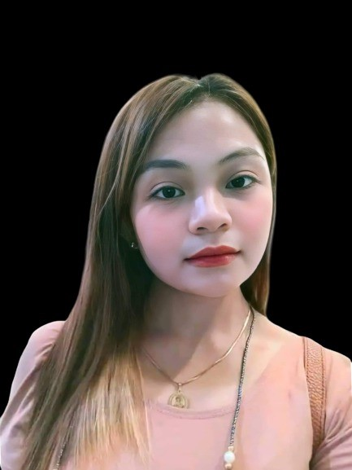

**Purok 6, Sitio San Jose Calomagon**

**Bulan Sorsogon**

**09129388750**

**balaorodona@gmail**.**com**

# DONA M. BALAORO

-Looking for a job in a reputable organization to utilize my skills for the growth of the organization as well as to further my knowledge.

-Pursuing opportunity which will allow me to grow professionally competetive while effectively utilizing my skill, set to help promote your mission and team goals.

## EXPERIENCE

**June 2019 - Present**

CCTV Operator - Laguna

**September 2022**

BDO LOAN BANK- Mandaluyong City

## JOB RESPONSIBILITIES

* Do Monitoring

* All Transactions Should be precise, accurate and true.

* Calling or CI Loan Applicant.

* Call Concerned department or Suppliers.

* Able to do some works given.

## EDUCATION

|  |  |  |
| --- | --- | --- |
| Specialization | : | BS Information Technology |
| College | : | Sorsogon State College- Bulan Campus  Bulan,  Sorsogon  April  2022 |
| Secondary | : | San Francisco National High School Bulan,  Sorsogon  March  2019 |
| Elementary | : | San Francisco Elementary School Bulan,  Sorsogon  March  2014 |

## SKILLS

* Strong desire to work and perform well.
* Effective Learners and can Multi-task any activities.
* Good written and Communication Skills
* Reliable, hardworking and trustworthy.
* Basic Networking
* Skilled in Microsoft Office Word,

Microsoft Office PowerPoint ,

Microsoft Office Excel

**PERSONAL INFORMATION**

|  |  |  |
| --- | --- | --- |
| Date of Birth | : | October 22, 2001 |
| Place of Birth | : | Bulan, Sorsogon |
| Age | : | 21 years old |
| Gender | : | Female |
| Civil Status | : | Single |
| Religion | : | Roman Catholic |

*I hereby certify that the above information is true and correct.*

DONA MIRA BALAORO

Applicant